Admin Panel
Anything highlighted in red, applies to all tabs.

Client Management –
-When exporting, the phone numbers with a + are not exporting correctly.
-Need a column for the admins to make notes.

Technician Management –
-We need information in all columns to be exported on every tab.
-Admin needs the ability to add/edit the profile picture for the technician.
-Need a column for the admins to make notes.
-Need to be able to filter Action column.
-Address format should be like the below picture on all tabs.
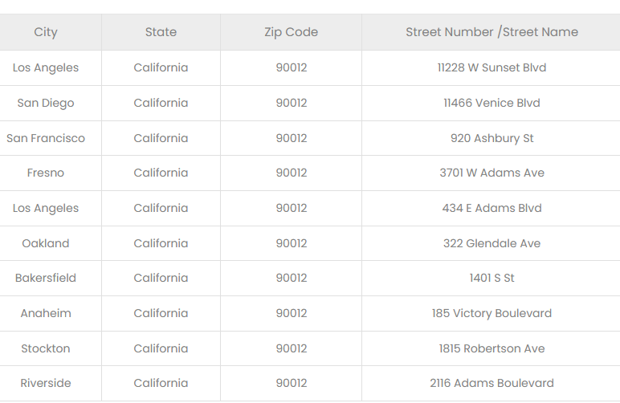

ID Verification –
-Should move off the list once approved. Should only list pending/denied requests.
-Need to have the option to deny or approve an applicant.
-Need a column for the admins to make notes.
-Need a column for the certifications to be uploaded by the tech.
Same as
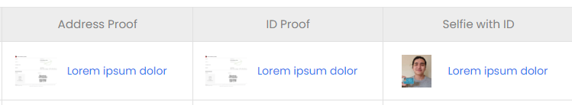

Membership Management –
-Need to have a column with the number of units at the location.
-Under status button, should say active, not activate.
- Should be able to export info.

Manage HVAC –
-Need an add Parts Button.
-Still not sure how we determine static and non-static pricing.
I don’t see an option to select static or non-static when exporting or editing a part.
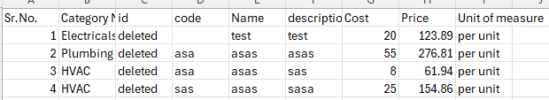
It seems like everything is being priced through the matrix. Some of our parts and materials have static prices. For example:
We have 3 filters. They all cost a different amount. We will price them the same amount regardless of cost. The static price items will bypass the matrix.
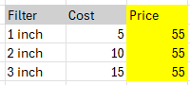
This is from the spreadsheet we sent originally.
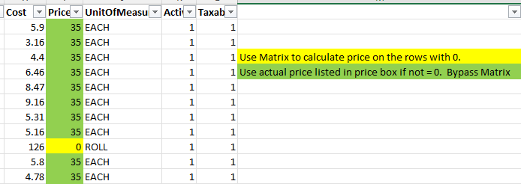

Manage Replacement –
-Need an Add Replacement button.
-Still need price column added
From original spreadsheet.

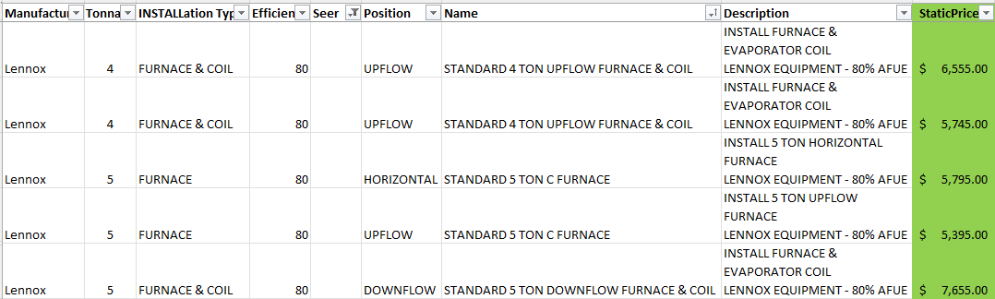

Contact Management -
When responding, the status automatically changes to Resolved.
Change Resolved to Respond/Responded and change Responded button to Resolved/Un resolved or something similar to this.
